**Under supervision of** :

Dr. Sherine Nagy

Eng: Hoda Osama

Eng: Mohamed Ramzy

**Presented By:**

Moustafa Shousha 19102675

Mahmoud Awad 19101863

|  |  |
| --- | --- |
| MODIFIED SIC ASSEMBLER |  |

**The Modi-SIC consists of:**

1. Same instructions set (Format 3) of SIC

2. Same idea of reservation of variables in memory using BYTE, WORD, RESB, RESW

**Modi-SIC is extended to include**

1. Format 1 instructions

2. Immediate Instruction (Format 3) that deals with an immediate value passed to as integer

**The input:**

the input reads file (with line numbers and comments) and generate an intermediate file by removing the comments, number lines and keep only assembly instruction with the labels and variables and every empty row should be deleted and if a row does not have an instruction is automatically deleted.

This intermediate file should be saved as (intermediate.txt), Here’s a sample of the input file.

**pass1:**

pass1 reads the intermediate file and produce: Location Counter for all program lines

followed by the generation of the symbol table

The program produces as output:

• (out_pass1.txt) that contains the corresponding location counter of the input Program

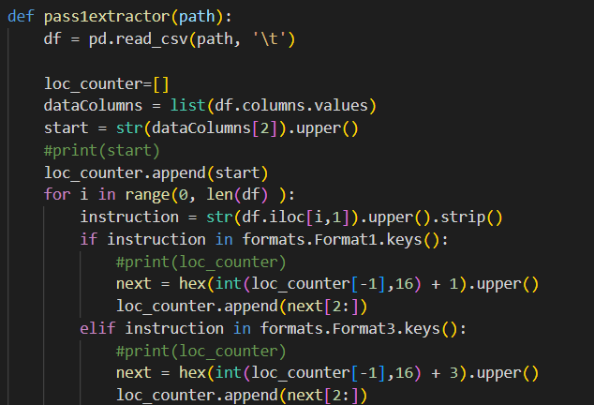• (symbTable.txt) that contains the symbol table output of the input program

**Pass2**

Pass 2 reads the intermediate file and produce: object code for all program lines followed by

the generation of the HTE record

The program produces as output:

• (out_pass2.txt) that contains the corresponding object code of the input program

• (HTE.txt) that contains the corresponding object code of the input program in HTE format.

**design issues:**

1) the input file must be TSV

2) if the last column in the input file is a comment then it must be no tab after it

3) if the last column in the input file is a value then it must be there a single tab after it

**How to use the Modi SIC :**

1. Choose a file with instruction, labels and variables separated by a TAB
2. Enter the path of the input file, then run the .bat file to excute the program
3. Then the program should export all the files needed as pass1, pass2, THE record succesfully